Choice of beta while Km=0.1

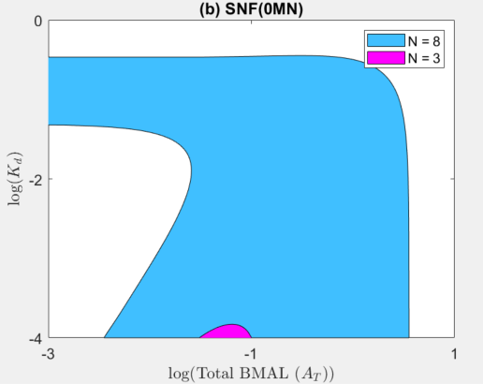

beta=4, Km=0.1

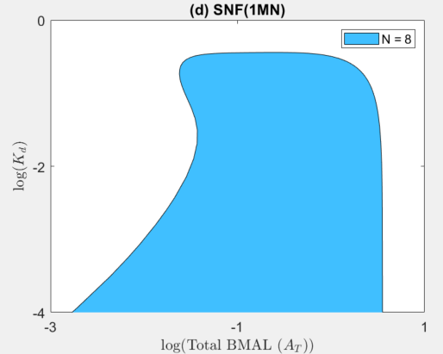

beta=4, Km=0.1, Ka=0.01 (N=3 no oscillatory region above Kd=0.0001)

